TO SUPPLY LEFT OVER FOOD THE POOR

### College Name: K G College Of Arts and Science

### College Code:

# TEAM ID: 90257E3C77C3016AAFB47CE55D65BC03

## TEAM MEMBERS:

# Team LeaderName: Divya.E

### Email: [2322jc19@kgcas.com](mailto:2322jc19@gmail.com)

## Team Member1: Durai Lingam.K

### Email: [2322jc20@kgcas.com](mailto:2322jc20@kgcas.com)

## Team Member2: Dharaneesh. K

### Email: [2322jc18@kgcas.com](mailto:2322jc18@kgcas.com)

## INTRODUCTION:

Food wastage is one of the major issues faced in our society, while at the same time many people struggle to get even a single meal a day. Every day, a large quantity of food from hotels, restaurants, hostels, and events goes to waste. If this leftover food is collected and distributed properly, it can help reduce hunger among the poor and needy.

This project aims to build a platform under the Naan Mudhalvan scheme to connect food donors (restaurants, hostels, marriage halls, households) with volunteers and NGOs who can collect and supply

the leftover food to the underprivileged. The system will ensure food safety, quick response, and efficient distribution so that surplus food is not wasted but reaches the right people at the right time.

Through this initiative, we not only reduce food wastage but also contribute to social welfare, support zero hunger goals, and bring smiles to those who are struggling for their daily meals.

* 1. Project Overview

The Leftover Food Supply System is designed to reduce food wastage and provide meals to the needy by creating a bridge between food donors and food seekers.

## C:\Users\shank\AppData\Local\Packages\5319275A.WhatsAppDesktop_cv1g1gvanyjgm\TempState\447D5C2BA3E790EC434C0BEE994095ED\WhatsApp Image 2025-09-04 at 19.01.05_eb9113a8.jpg**1.2** Purpose

## Creating Developer Account:

### By using this URL: <https://www.salesforce.com/form/developer-signup/?d=pb>

*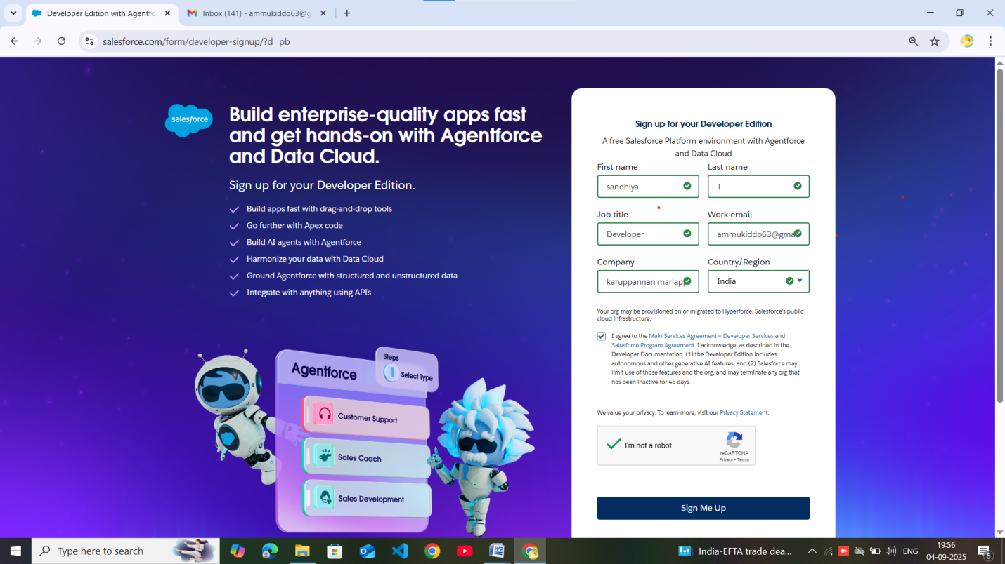*

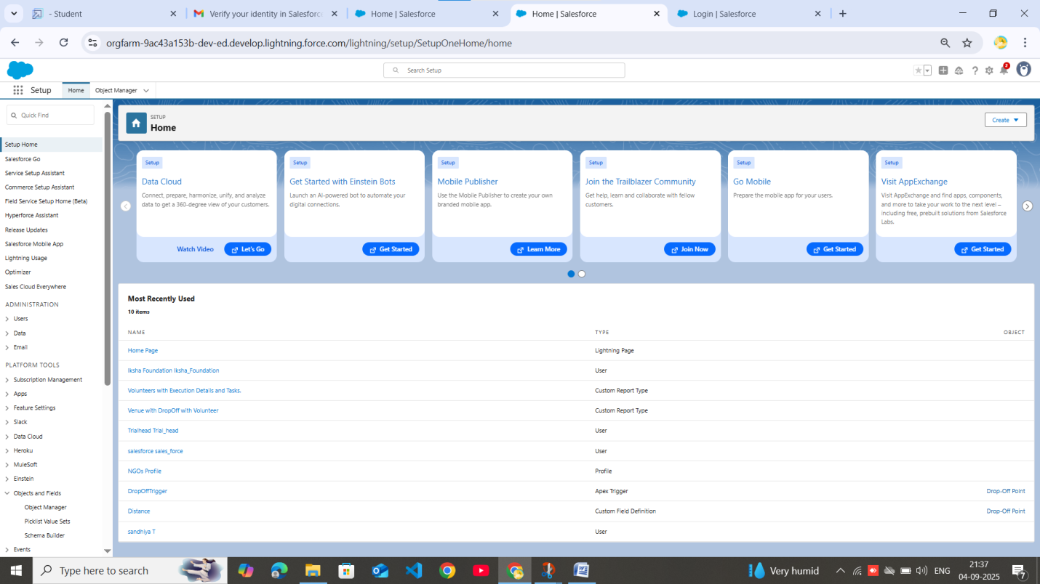 . OBJECT: Venue,Drop-Off Point,Taks,volunteer,Execution Details.

# VENUE:

# DROP-OFF POINT:

# TASK:

# VOLUNTEER:

# EXECUTION DETAIL:

# . TABS:

### Creating a Custom Tab

## 

### 

### 

### . The Lightning App

### Create a Lightning App

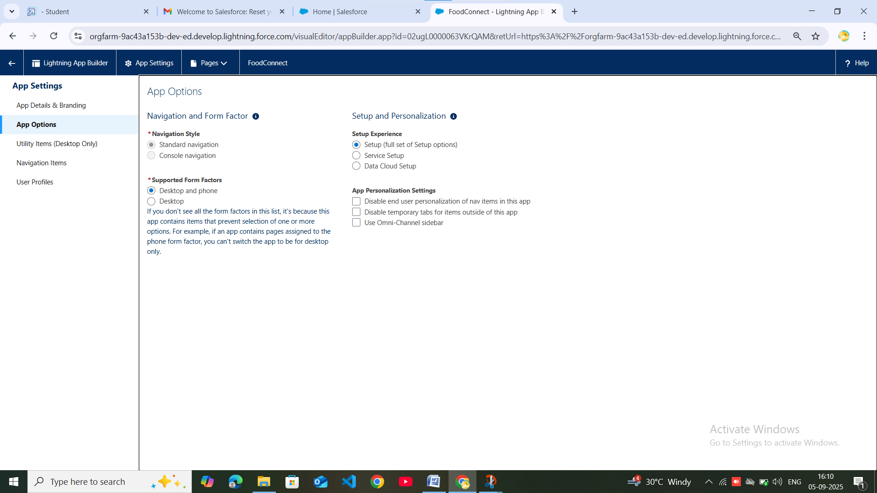

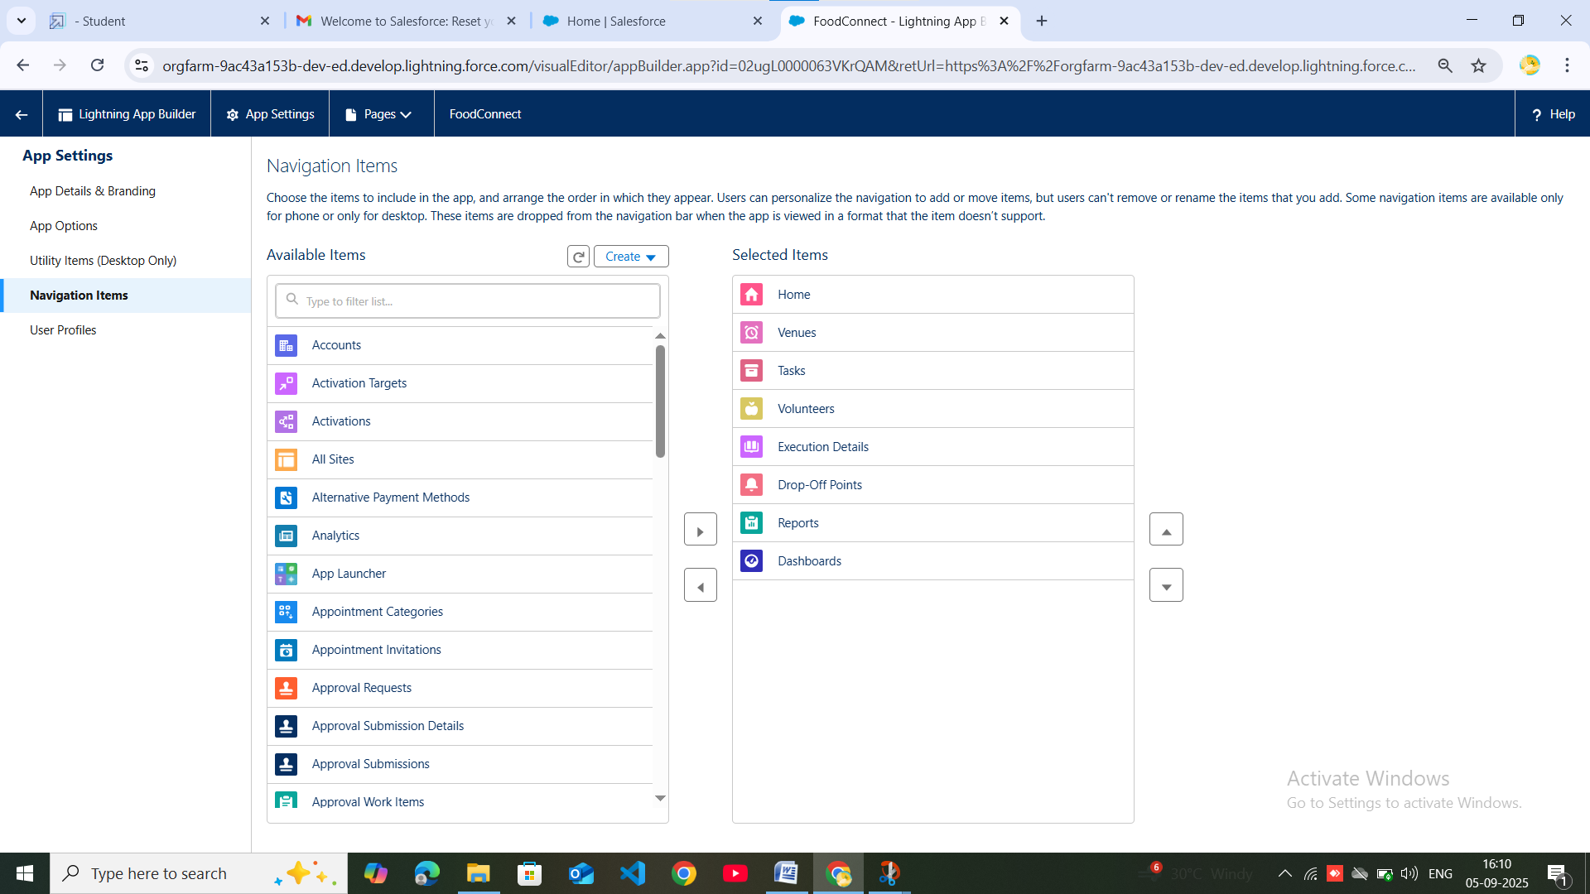

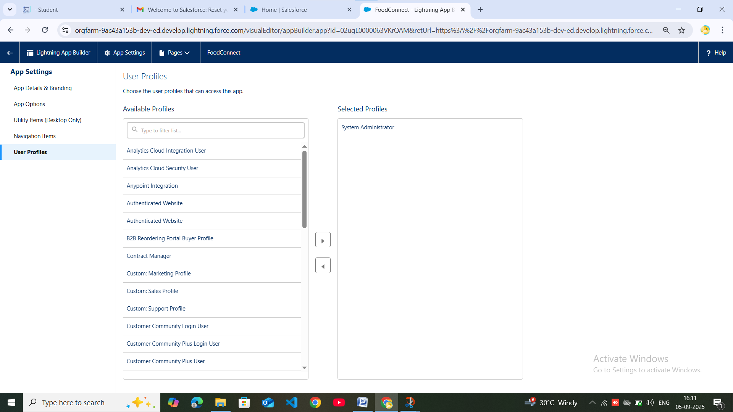

### . FIELDS:

### Creation of Relationship fields in objects

# 1.Venue

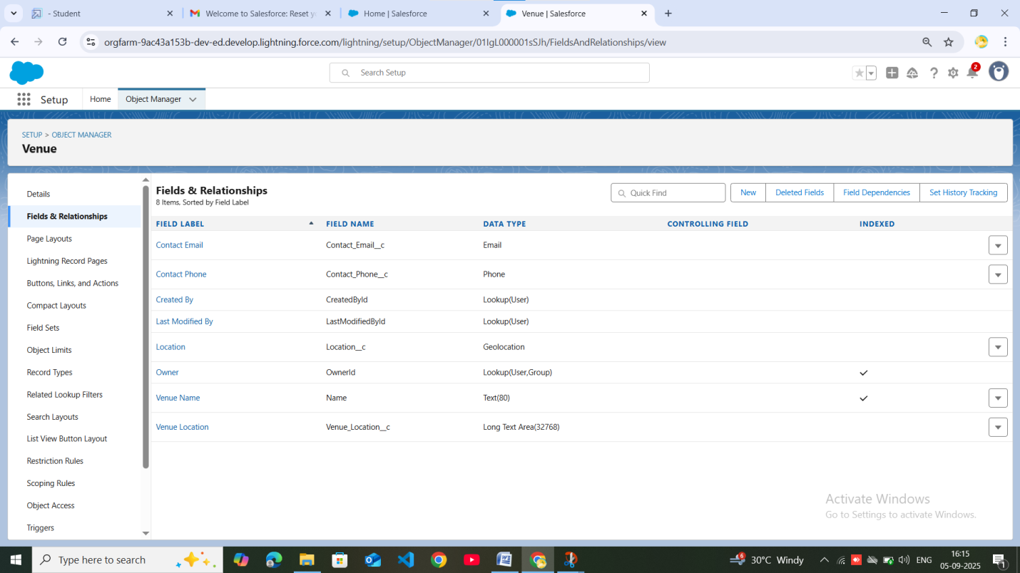

# 2. Drop-Off Point

# 3. Tasks

# 4. Execution details

# 5. Volunteers

# . FLOWS:

### Create Flow to create a record in Venue object

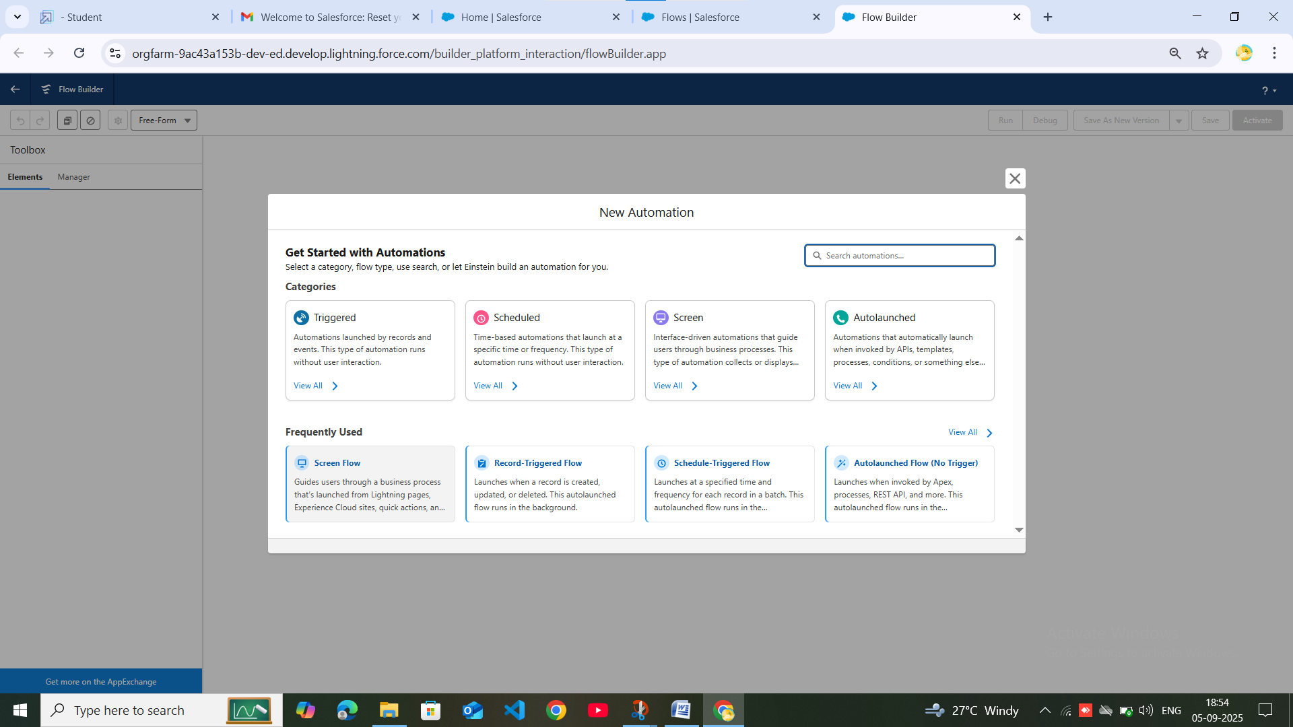

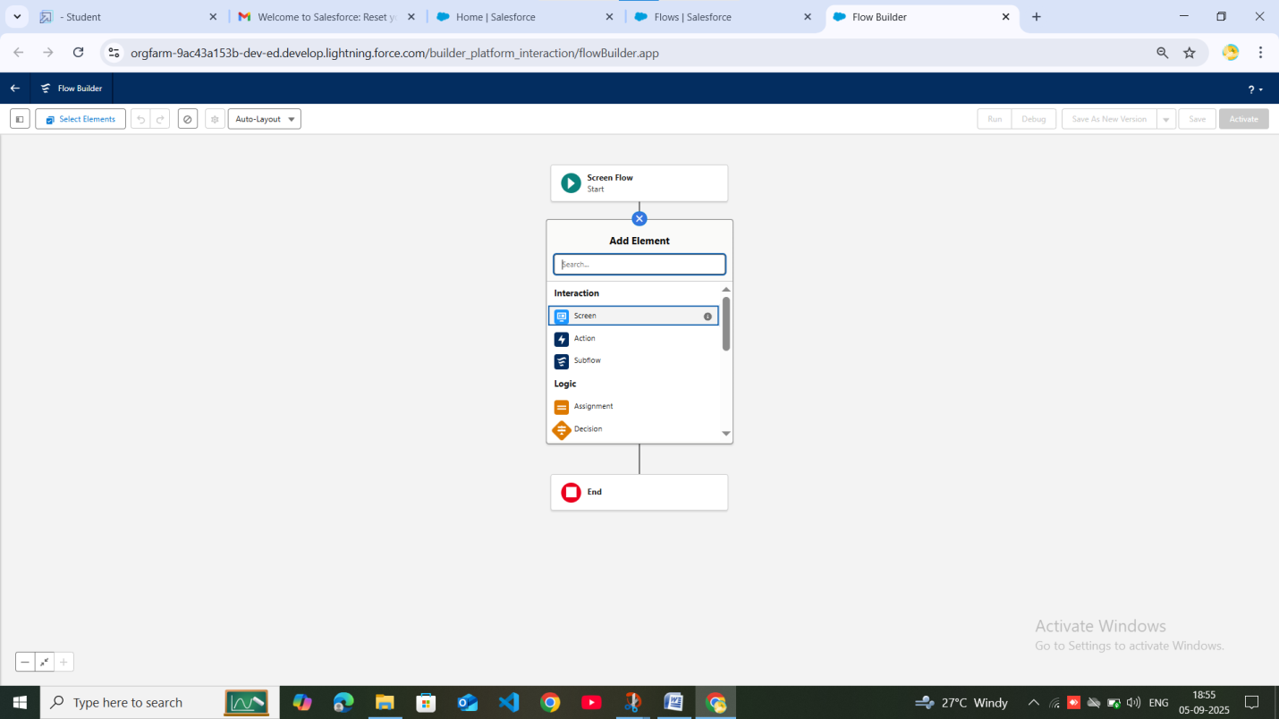

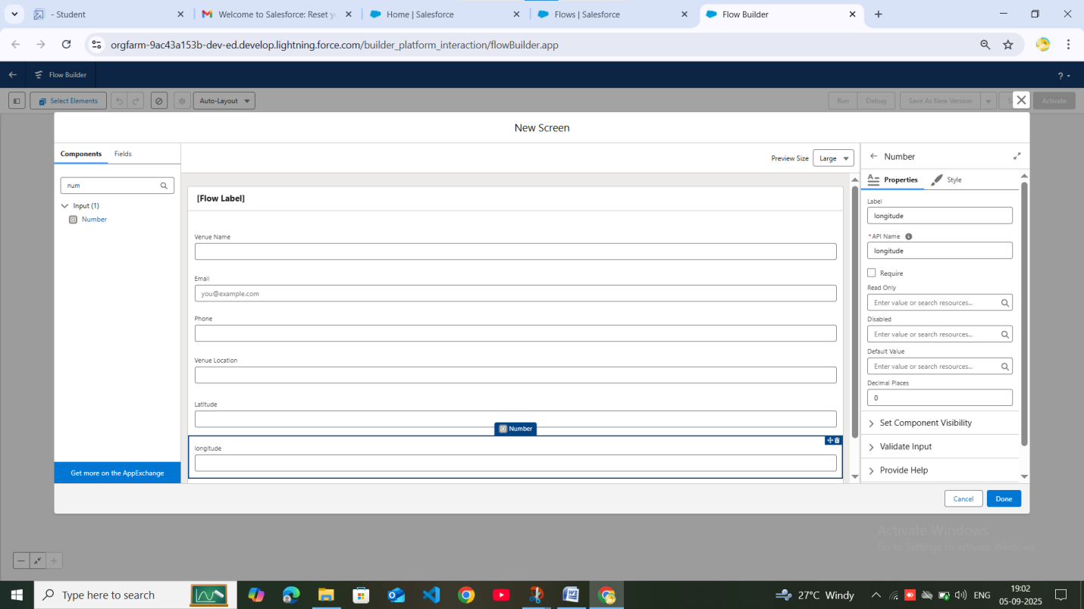

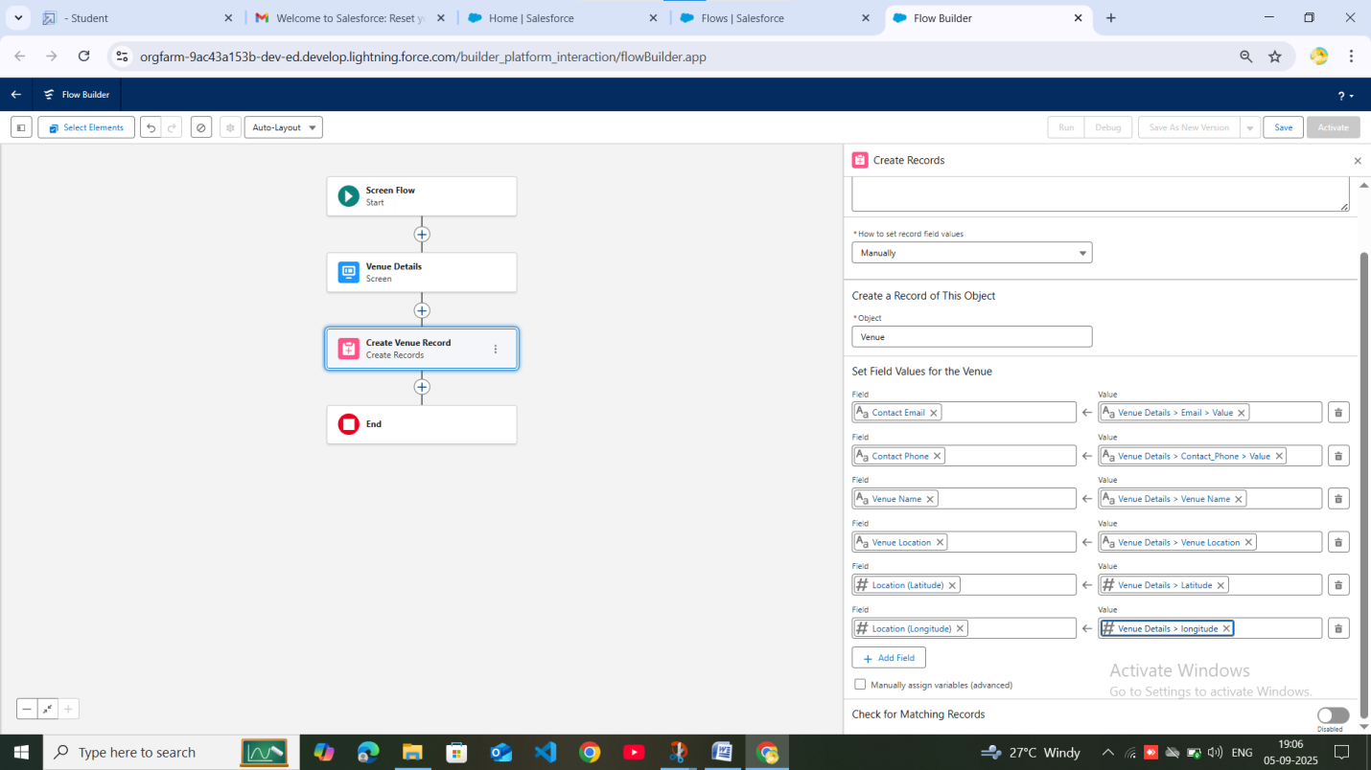

# . TRIGGERS:

### Create a Trigger

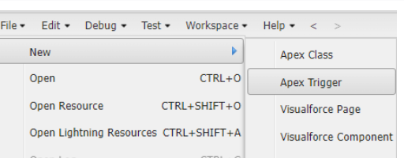

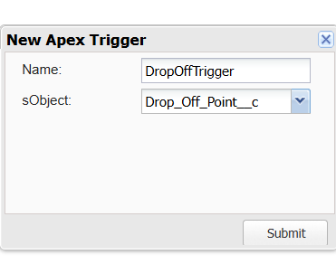

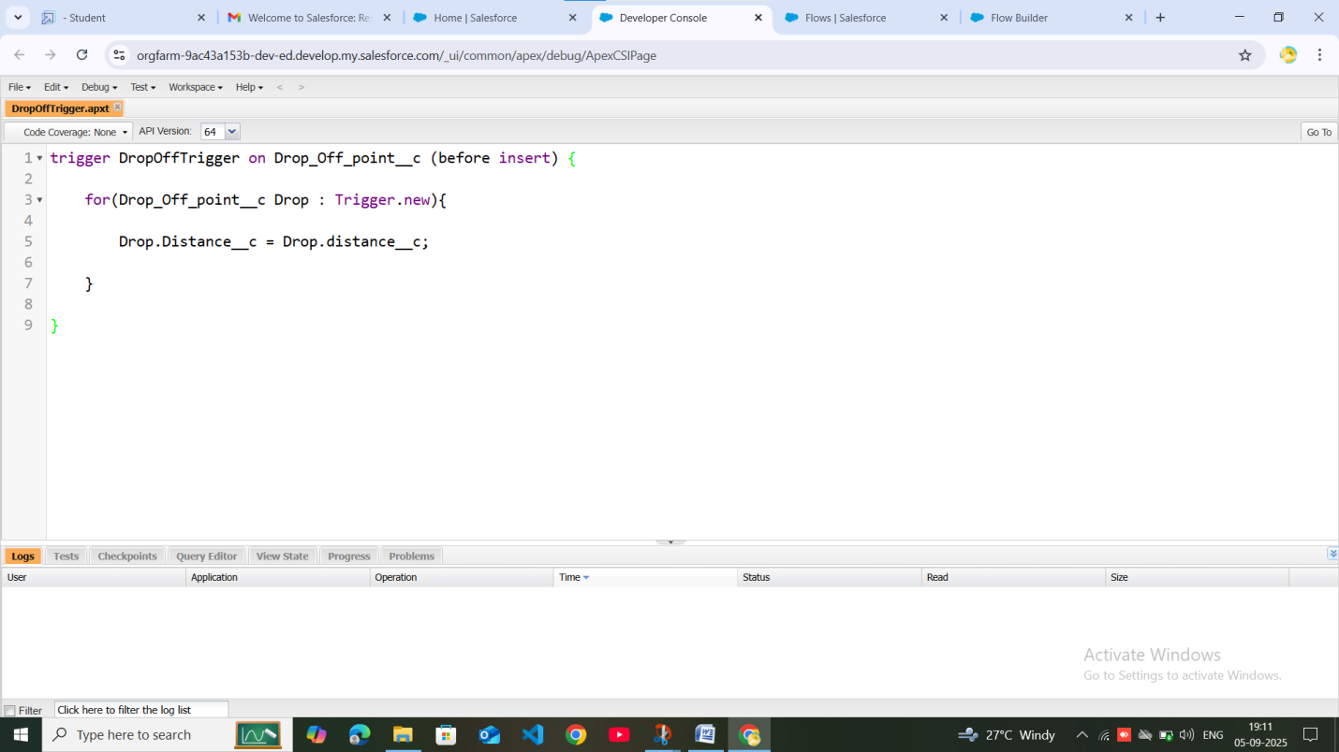

# . PROFILES:

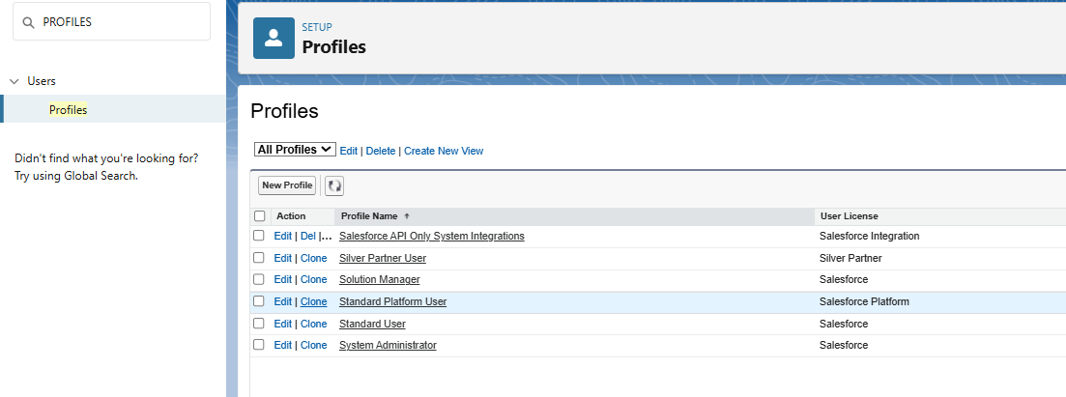

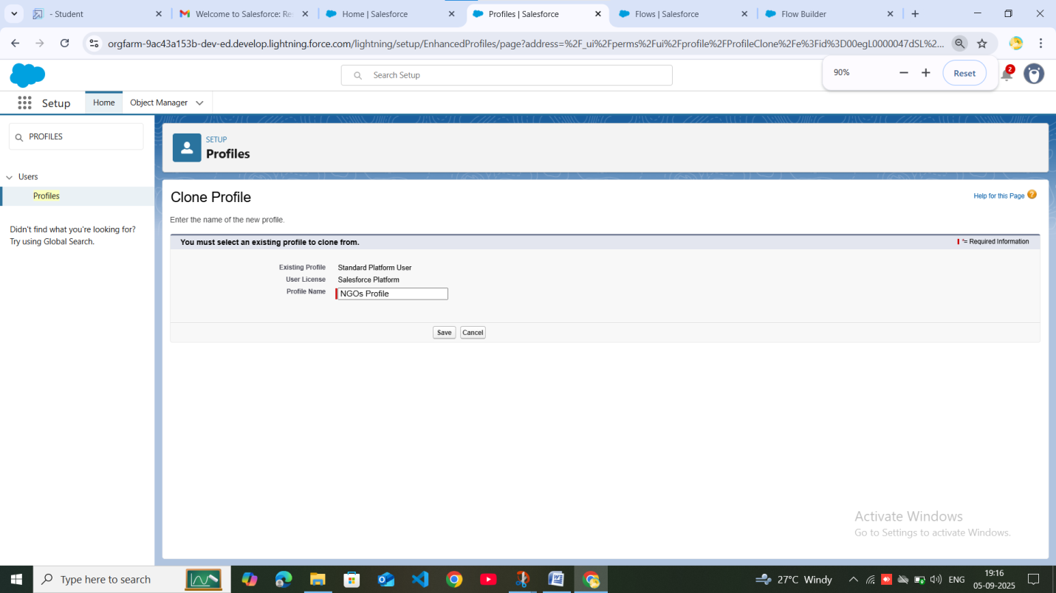

# . CREATION OF USERS:

### Creation of User1

Creation of User2 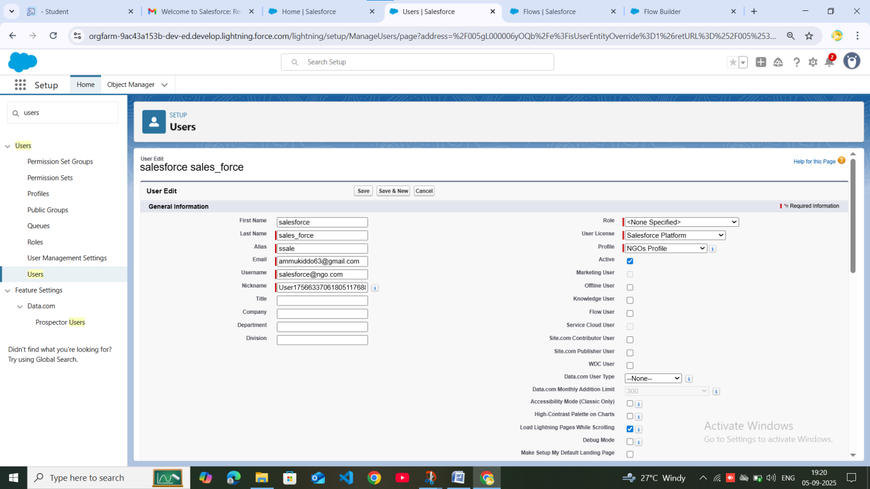

Creation of User3 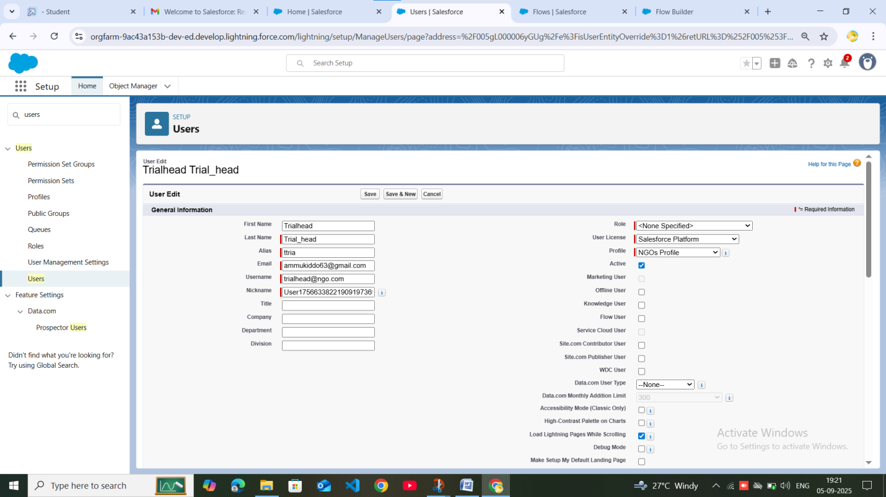

## . PUBLIC GROUPS:

### Creation of Public Group 1

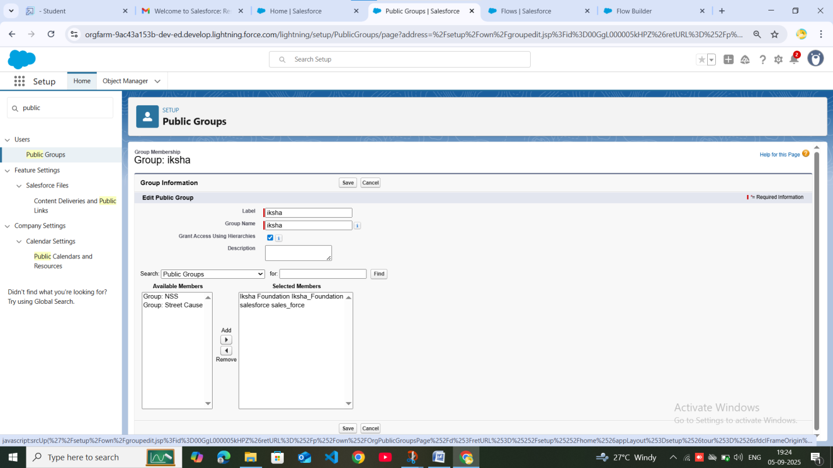

### Creation of Public Group 2

Creation of Public Group 3 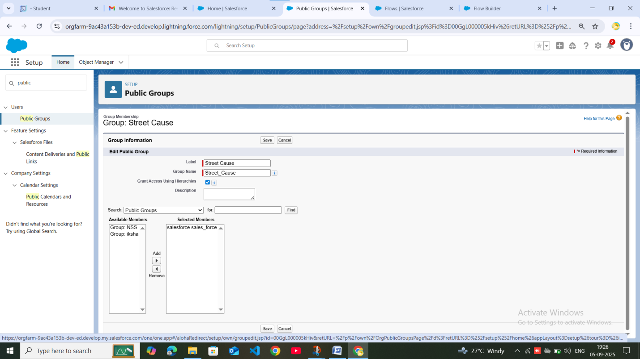

# . REPORT TYPS:

### Creation of Report Types

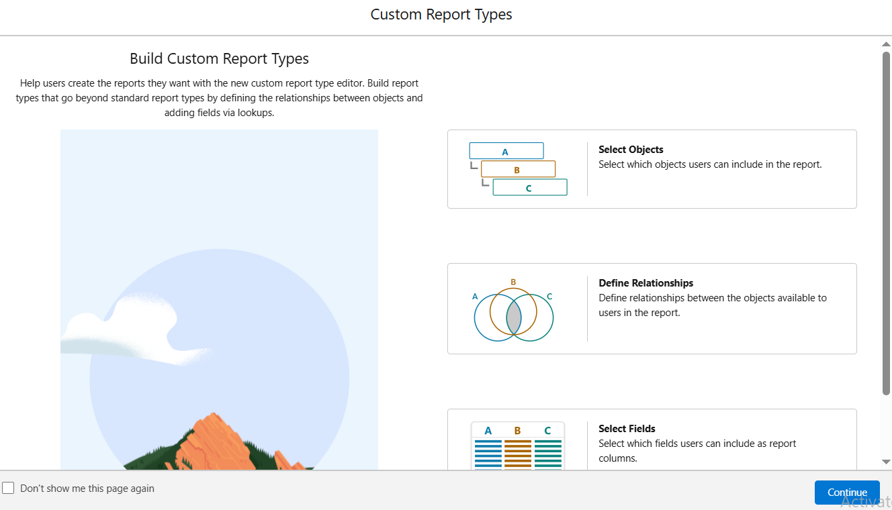

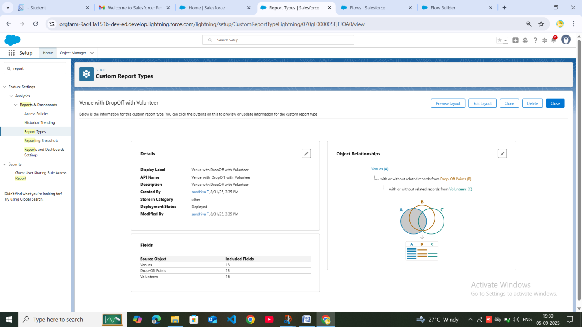

# . REPORTS:

### Creation of Report on Venue with DropOff with Volunteer

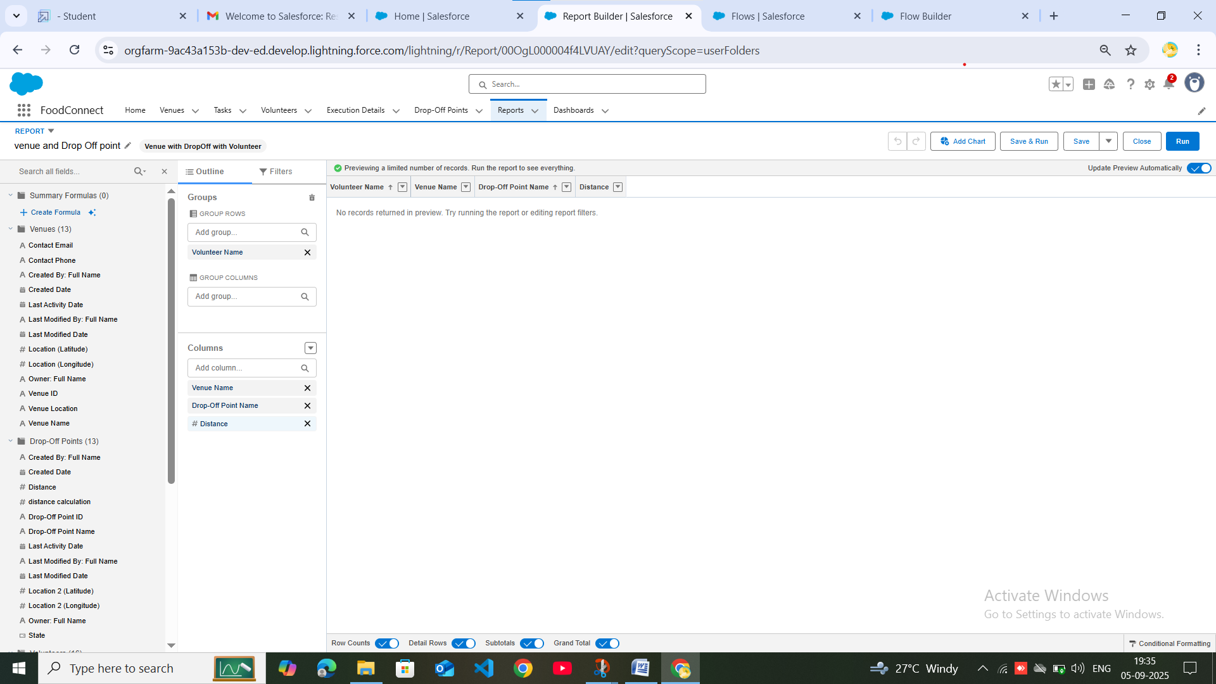

### Creation of Report on Volunteers with Execution Details and Tasks

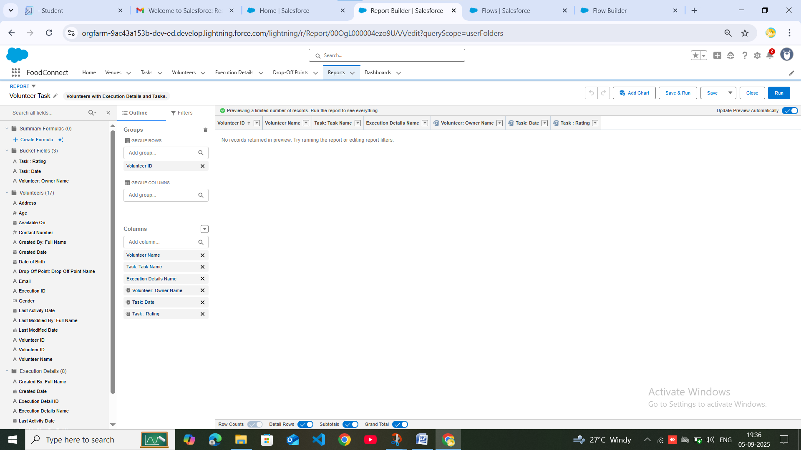

# . DASHBOARDS:

### Adding venue and Drop Off point Report to the Dashboard

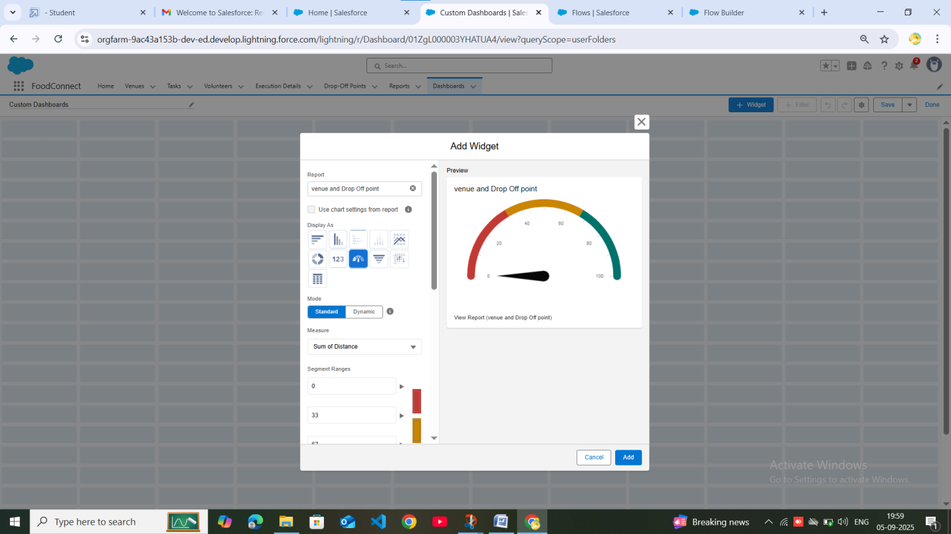

### Adding Volunteer Task Report to the Dashboard

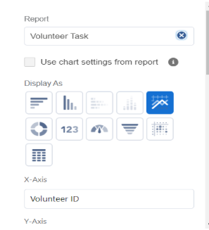 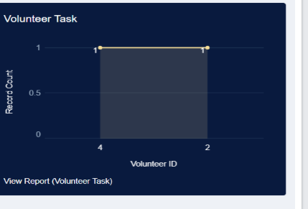

## . SHARING RULES:

### Creation of sharing rules:

## Rule 1

## Rule 2

## Rule 3



# . HOME PAGE:

### Creation of Home Page

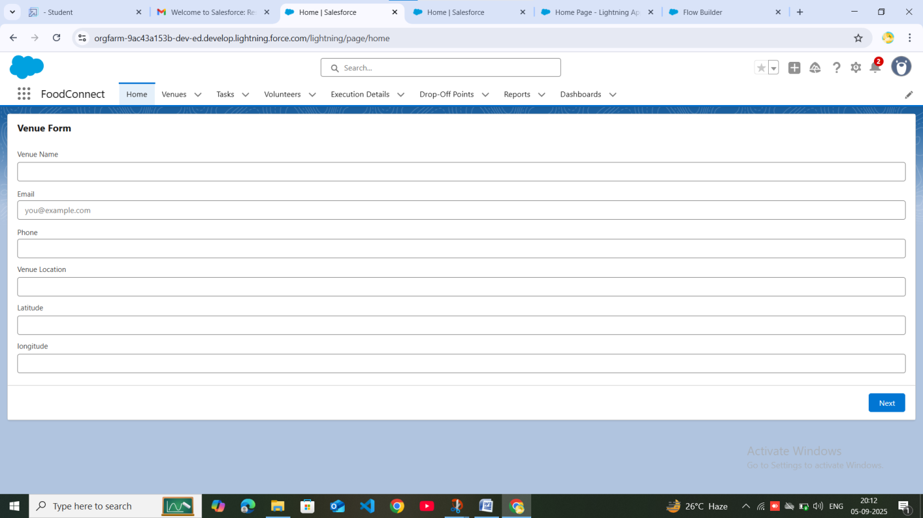

# . ADVANTAGE:

1. Reduces Food Wastage – Surplus food is utilized instead of being thrown away.

2. Helps Poor & Needy – Provides meals to underprivileged people.

3. Promotes Social Responsibility – Encourages individuals, hotels, and organizations to contribute to society.

4. Cost-Effective – No extra production cost, as food is already available.

5. Supports Sustainable Goals – Contributes to “Zero Hunger” and reduces environmental impact of food waste.

6. Builds Community Support – Creates a connection between donors, NGOs, and society.

# . DISADVANTAGE:

1. Food Safety Concerns – Risk of serving spoiled or contaminated food if not handled properly.

2. Logistics Issues – Timely collection and delivery can be challenging.

3. Dependence on Volunteers – Requires active NGO/volunteer participation for success.

4. Limited Storage – Perishable food must be distributed quickly, which may cause wastage if demand is less.

5. Awareness Gap – Many potential donors may not be aware of the platform or may hesitate to share food.

# CONCLUSION:

This project highlights the importance of reducing food wastage and utilizing surplus food to serve society. By creating a platform that connects food donors with NGOs and volunteers, leftover food can be effectively collected and distributed to the poor and needy. The system ensures that edible food is not wasted but reaches those who are struggling to get daily meals.

Through this initiative, we can not only minimize hunger but also promote social responsibility, community welfare, and environmental sustainability. This project contributes to the vision of “Zero Hunger” and sets an example of how technology can be used for a meaningful social cause.